WEEK 1: Ques 1

Write a program to create a child process using system call fork().

SOURCE CODE:

#include <stdio.h>
#include <unistd.h>
#include <sys/types.h>

int main() {
pid_t pid=fork();
printf("Parent Process ID: %d\n",getppid());
printf("Child Process ID: %d\n",getpid());
return 0;
}

OUTPUT:

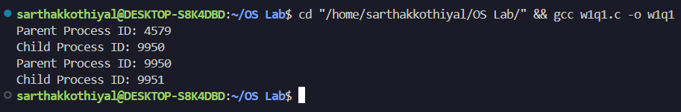

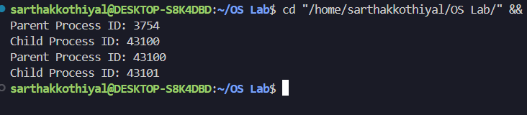

WEEK 1: Ques 2

Write a program to print process Id's of parent and child process i.e. parent should print its own and its child process id while child process should print its own and its parent process id. (use getpid(), getppid())

SOURCE CODE:
#include <stdio.h>
#include <unistd.h>
#include <sys/types.h>
#include <sys/wait.h>

int main() {
pid_t pid;
pid=fork();
if(pid<0){ // fork failed
printf("Fork failed...");
return 1;
}
else if(pid==0){ // child process
printf("This is the child process...\n");
printf("Process ID of Child: %d\n",getpid());
printf("Process ID of Parent: %d\n",getppid());
}
else{ // parent process
printf("This is the parent process...\n");
printf("Process ID of Parent: %d\n",getpid());
printf("Process ID of Child: %d\n",pid);
wait(NULL); // To void zombie process
}
return 0;
}
OUTPUT:

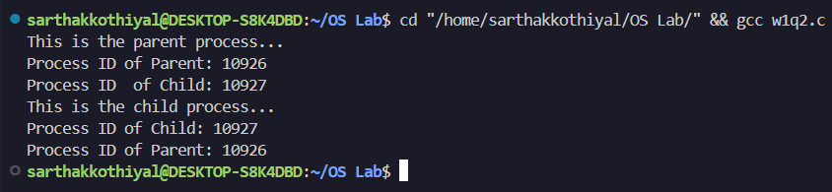

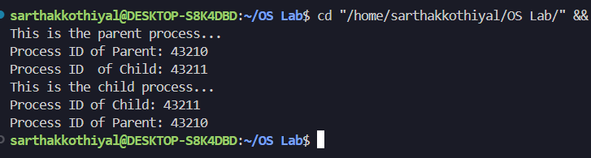

WEEK 1: Ques 3

Write a program to create child process which will list all the files present in your system. Make sure that parent process waits until child has not completed its execution. (use wait(), exit()). What will happen if parent process dies before child process? Illustrate it by creating one more child of parent process.

SOURCE CODE:

#include <stdio.h>
#include <stdlib.h>
#include <unistd.h>
#include <sys/wait.h>

int main(){
pid_t p1,p2;
p1=fork();
if(p1<0){
printf("Process Not Created!!!\n");
exit(1);
}
if(p1==0){
printf("Child 1 ID: %d, used to print files...\n",getpid());
execlp("ls","ls","-l",(char*)NULL);
exit(1);
}
else{
wait(NULL); // parent will wait till one of it's child process is not completed
printf("Parent ID: %d\n",getpid());
printf("Child has finished its execution...\n");
p2=fork(); // new process to demonstrate completion of parent before child
if(p2<0){
printf("Process Not Created!!!\n");
exit(1);
}
if(p2==0){
sleep(5);
printf("Child 2 ID: %d\n",getpid());
printf("Parent ID of Child 2: %d\n",getppid());
}
else{
printf("Completed chlild 2 of Parent: %d\n",getpid());
exit(0);
}
}
return 0;
}

OUTPUT:

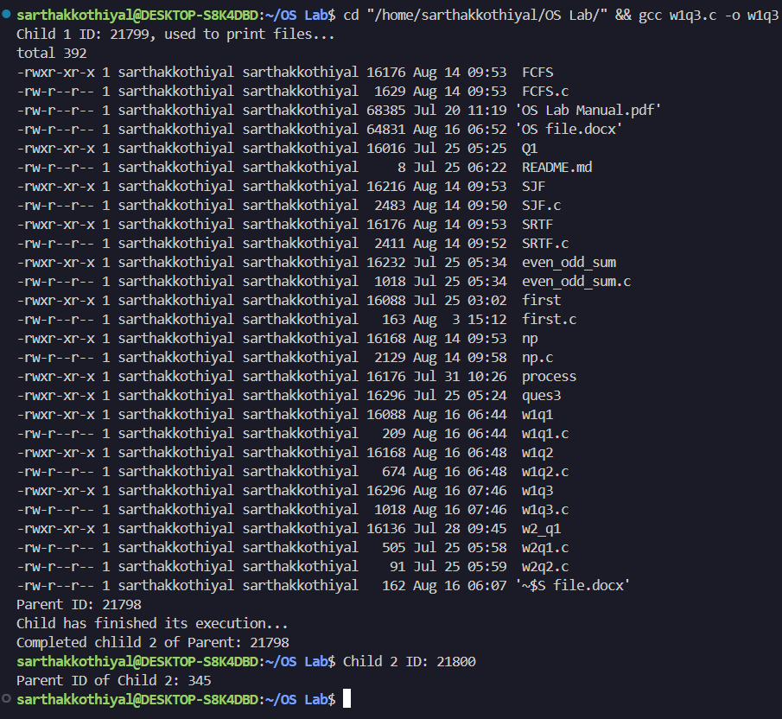

WEEK 2: Ques 1

Write a program to open a directory and list its contents. (use opendir(), readdir(), closedir())

SOURCE CODE:

#include <dirent.h>
#include <unistd.h>
#include <stdio.h>
#include <stdlib.h>
int main(){
DIR *dir;
struct dirent *entry;
dir=opendir(".");
if(dir==NULL){
printf("Error opening the Directory...\n");
exit(1);
}
else{
printf("Listing all File names in current directory...\n");
while((entry=readdir(dir))!=NULL){
printf("%s\n",entry->d_name);
}
closedir(dir);
printf("All files Listed...\n");
}
return 0;
}

OUTPUT:

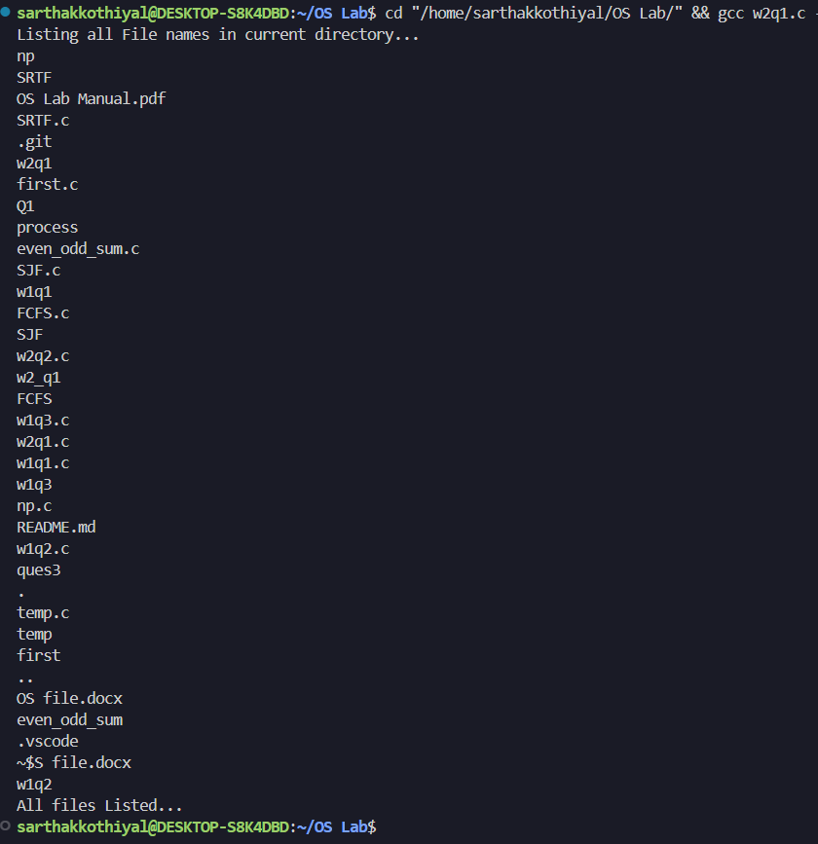

WEEK 2: Ques 2

Write a program to show working of execlp() system call by executing ls command.

SOURCE CODE:

#include <stdio.h>
#include <unistd.h>
#include <stdlib.h>
int main() {
printf("Executing ls command using execlp():\n");
if (execlp("ls", "ls", "-l", NULL) == -1) {
perror("execip failed");
return 1;
}
printf("This will not be printed if execlp() executes successfully.\n");
return 0;
}

OUTPUT:

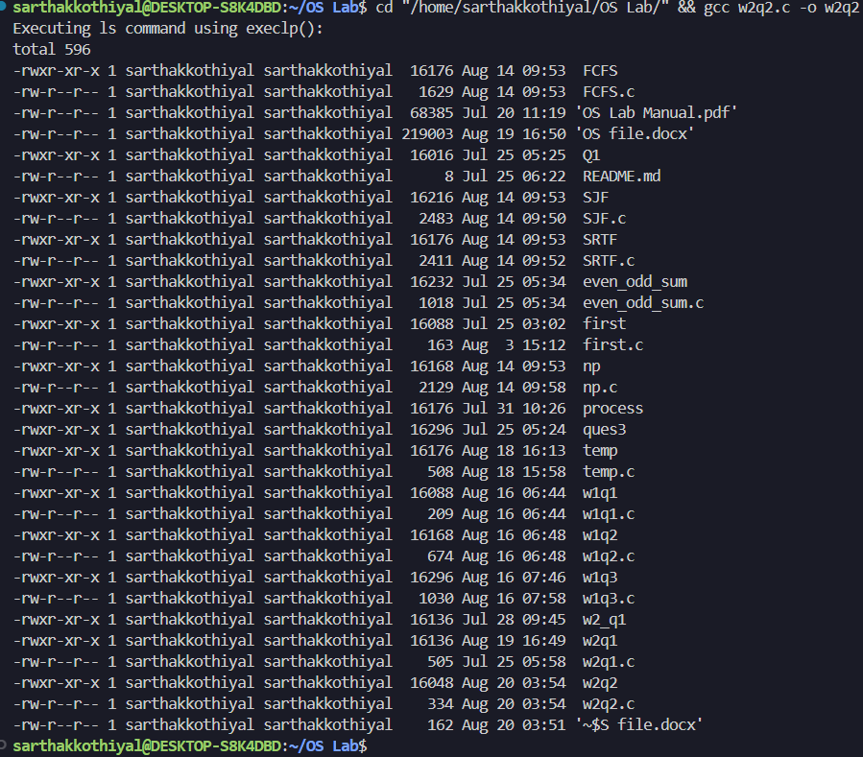

WEEK 2: Ques 3

Write a program to read a file and store your details in that file. Your program should also create one more file and store your friend’s details in that file. Once both files are created, print lines which are matching in both files.

SOURCE CODE:

#include <stdio.h>
#include <string.h>
#define MAX_LINE_LENGTH 256

void write_details_to_file(const char *filename, const char *details[], int num_details) {
FILE *file = fopen(filename, "w");
if (file == NULL) {
perror("Error opening file");
return;
}
for (int i = 0; i < num_details; i++) {
fprintf(file, "%s\n", details[i]);
}
fclose(file);
}

void find_matching_lines(const char *file1, const char *file2) {
FILE *f1 = fopen(file1, "r");
FILE *f2 = fopen(file2, "r");
if (f1 == NULL || f2 == NULL) {
perror("Error opening files");
return;
}

char line1[MAX_LINE_LENGTH];
char line2[MAX_LINE_LENGTH];
while (fgets(line1, sizeof(line1), f1)) {
fseek(f2, 0, SEEK_SET);
while (fgets(line2, sizeof(line2), f2)) {
line1[strcspn(line1, "\n")] = 0;
line2[strcspn(line2, "\n")] = 0;
if (strcmp(line1, line2) == 0) {
printf("Matching line: %s\n", line1);
}
}
}
fclose(f1);
fclose(f2);
}

int main() {
const char *my_details[] = {
"Name: Sarthak Kothiyal",
"Roll No: 2319517",
"Course: CS",
"Age: 20"
};
int my_details_count = sizeof(my_details) / sizeof(my_details[0]);

const char *friends_details[] = {
"Name: Friend",
"Roll No: 12345",
"Course: CS",
"Age: 20"
};

int friends_details_count = sizeof(friends_details) / sizeof(friends_details[0]);
write_details_to_file("my_details.txt", my_details, my_details_count);
write_details_to_file("friends_details.txt", friends_details, friends_details_count);
printf("\nMatching lines between my_details.txt and friends_details.txt:\n");
find_matching_lines("my_details.txt", "friends_details.txt");
return 0;
}

OUTPUT:

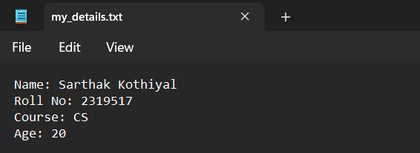
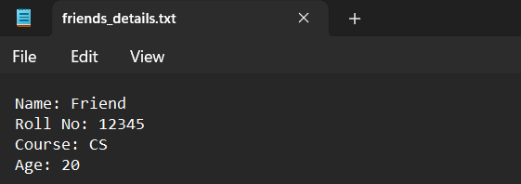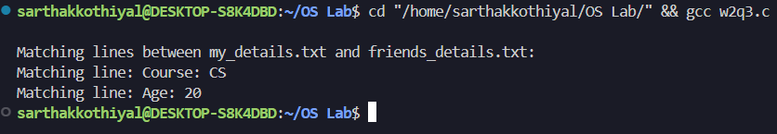

WEEK 3: Ques 1

FCFS – First Come First Served : process which arrives first will get the CPU first.

SOURCE CODE:

#include <stdio.h>
#include <stdlib.h>
#include <unistd.h>
typedef struct process{
int id;
int arrival_time;
int burst;
int starting_time;
int completion_time;
int turn_around;
int util_time;
int response_time;
int waiting_time;
}process;
int cmp(const void* a, const void* b){
process* p1=(process*)a;
process* p2=(process*)b;
return p1->arrival_time-p2->arrival_time;
}
int main(){
int n;
printf("Enter the number of Processes: ");
scanf("%d",&n);
process P[n];
printf("Enter Arrival Time: ");
for(int i=0;i<n;i++){
scanf("%d",&P[i].arrival_time);
P[i].id=i;
}
printf("Enter Burst Time: ");
for(int i=0;i<n;i++){
scanf("%d",&P[i].burst);
}
qsort(P,n,sizeof(process),cmp);
int time=0;
for(int i=0;i<n;i++){
if(time<P[i].arrival_time){
time=P[i].arrival_time;
}
P[i].starting_time=time;
P[i].completion_time=time+P[i].burst;
P[i].turn_around=P[i].completion_time-P[i].arrival_time;
P[i].util_time=P[i].turn_around-P[i].burst;
time=P[i].completion_time;
P[i].response_time=P[i].starting_time-P[i].arrival_time;
P[i].waiting_time=P[i].turn_around-P[i].burst;
}
printf("Gantt Chart...\n");
for(int i=0;i<n;i++){
printf("P%d ", P[i].id);
}
printf("\n");
printf("Process ID\tArrival\tBurst\tStart\tCompletion\tResponse\tTAT\tWaiting\n");
for(int i=0;i<n;i++){
printf("%d\t\t%d\t%d\t%d\t%d\t\t%d\t\t%d\t%d\n",P[i].id,P[i].arrival_time,P[i].burst,P[i].starting_time,P[i].completion_time,P[i].response_time,P[i].turn_around,P[i].waiting_time);
}
return 0;
}

OUTPUT:

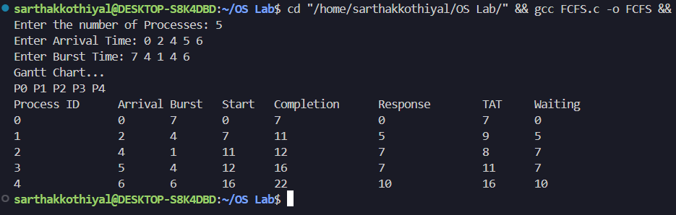

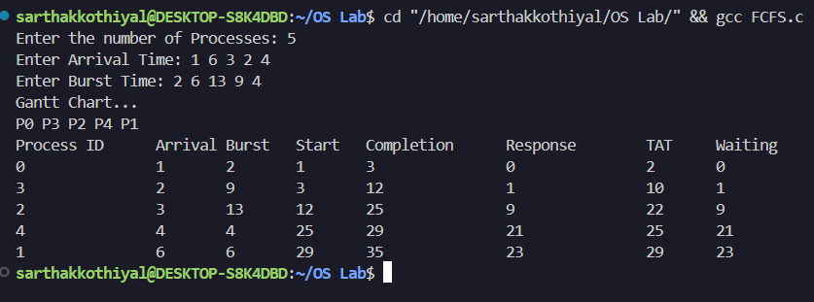

WEEK 3: Ques 2

SJF NP – Shortest Job First Non-Preemptive : process which needs CPU for least amount will get the CPU first. Here non-preemptive means currently running process leaves CPU voultarily after completing its execution.

SOURCE CODE:

#include <stdlib.h>
#include <stdio.h>
#include <unistd.h>
#include <stdbool.h>
#include <limits.h>

typedef struct process{
int id;
int arrival_time;
int burst;
int starting_time;
int completion_time;
int turn_around;
int waiting_time;
int response_time;
}process;
int cmp(const void* a, const void* b){
process* p1=(process*)a;
process* p2=(process*)b;
return p1->arrival_time-p2->arrival_time;
}
int main(){
int n;
printf("Enter number of Processes: ");
scanf("%d",&n);
bool *iscompleted=(bool*)malloc(n*sizeof(bool));
for(int i=0;i<n;i++)iscompleted[i]=false;
bool is_first_process=true;
process P[n];
printf("Enter Arrival Time: ");
for(int i=0;i<n;i++){
scanf("%d",&P[i].arrival_time);
P[i].id=i;
}
printf("Enter Burst Time: ");
for(int i=0;i<n;i++){
scanf("%d",&P[i].burst);
}
qsort(P,n,sizeof(process),cmp);
int time=0;
int completed=0;
while(completed!=n){
int min_index=-1;
int minimum=INT_MAX;
for(int i=0;i<n;i++){
if(P[i].arrival_time<=time && !iscompleted[i]){
if(P[i].burst<minimum){
minimum=P[i].burst;
min_index=i;
}
if(P[i].burst==minimum){
if(P[i].arrival_time<P[min_index].arrival_time){
minimum=P[i].burst;
min_index=i;
}
}
}
}
if(min_index==-1){
time++;
}
else{
completed++;
iscompleted[min_index]=true;
P[min_index].starting_time=time;
P[min_index].completion_time=P[min_index].starting_time+P[min_index].burst;
P[min_index].turn_around=P[min_index].completion_time-P[min_index].arrival_time;
P[min_index].waiting_time=P[min_index].turn_around-P[min_index].burst;
P[min_index].response_time=P[min_index].starting_time-P[min_index].arrival_time;
time+=P[min_index].burst;
}
}
printf("Gantt Chart...\n");
for(int i=0;i<n;i++){
printf("P%d ", P[i].id);
}
printf("\n");
printf("Process ID\tArrival\tBurst\tStart\tCompletion\tResponse\tTAT\tWaiting\n");
for(int i=0;i<n;i++){
printf("%d\t\t%d\t%d\t%d\t%d\t\t%d\t\t%d\t%d\n",P[i].id,P[i].arrival_time,P[i].burst,P[i].starting_time,P[i].completion_time,P[i].response_time,P[i].turn_around,P[i].waiting_time);
}
return 0;
}

OUTPUT:

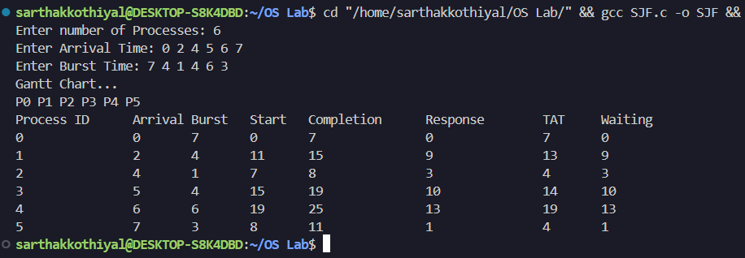

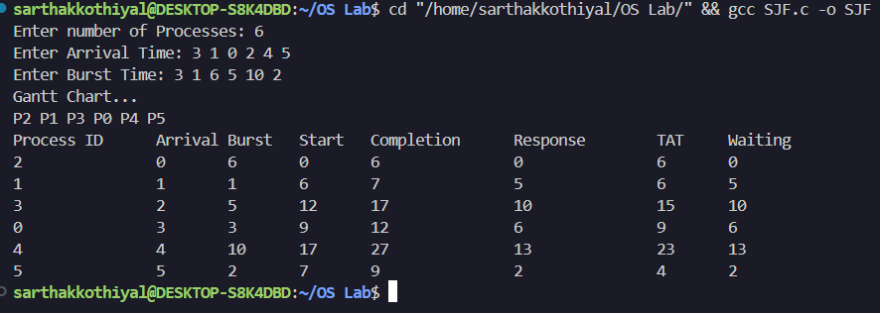

WEEK 3: Ques 3

SJF P – Shortest Job First Preemptive – Here preemptive means operating system decides
when to move currently running process

SOURCE CODE:

#include <stdio.h>
#include <stdlib.h>

typedef struct process{
int id;
int arrival_time;
int burst;
int starting_time;
int completion_time;
int turn_around;
int waiting_time;
int remaining_time;
int response_time;
int started;
}process;

int cmp(const void* a,const void* b){
process* p1=(process*)a;
process* p2=(process*)b;
return p1->arrival_time-p2->arrival_time;
}
int main(){
int n;
printf("Enter the number of Processes: ");
scanf("%d",&n);
process P[n];
printf("Enter Arrival Time: ");
for(int i=0;i<n;i++){
scanf("%d",&P[i].arrival_time);
P[i].id=i;
P[i].started=0;
}
printf("Enter Burst Time: ");
for(int i=0;i<n;i++){
scanf("%d",&P[i].burst);
P[i].remaining_time=P[i].burst;
}
qsort(P,n,sizeof(process),cmp);
int time=0,completed=0;
int gantt[1000],gsize=0;
while(completed<n){
int min_index=-1;
for(int i=0;i<n;i++){
if(P[i].arrival_time<=time && P[i].remaining_time>0 && (min_index==-1 || P[i].remaining_time<P[min_index].remaining_time)){
min_index=i;
}
}
if(min_index!=-1){
if(P[min_index].started==0){
P[min_index].starting_time=time;
P[min_index].response_time=time-P[min_index].arrival_time;
P[min_index].started=1;
}
P[min_index].remaining_time--;
gantt[gsize++]=P[min_index].id;
time++;
if(P[min_index].remaining_time==0){
completed++;
P[min_index].completion_time=time;
P[min_index].turn_around=time-P[min_index].arrival_time;
P[min_index].waiting_time=P[min_index].turn_around-P[min_index].burst;
}
}
else{
gantt[gsize++]=-1;
time++;
}
}
double avgwait=0.0,avgtat=0.0;
for(int i=0;i<n;i++){
avgwait+=P[i].waiting_time;
avgtat+=P[i].turn_around;
}
avgwait/=n;
avgtat/=n;
printf("Gantt Chart...\n");
for(int i=0;i<gsize;i++){
if(gantt[i]==-1) printf("IDLE ");
else printf("P%d ",gantt[i]);
}
printf("\n");
printf("Process ID\tArrival\tBurst\tStart\tCompletion\tResponse\tTAT\tWaiting\n");
for(int i=0;i<n;i++){
printf("%d\t\t%d\t%d\t%d\t%d\t\t%d\t\t%d\t%d\n",P[i].id,P[i].arrival_time,P[i].burst,P[i].starting_time,P[i].completion_time,P[i].response_time,P[i].turn_around,P[i].waiting_time);
}
printf("Average Waiting Time: %.2f\n",avgwait);
printf("Average Turn Around Time: %.2f\n",avgtat);
return 0;
}
OUTPUT:

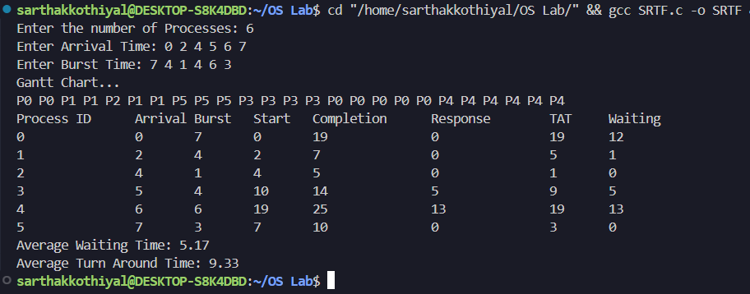

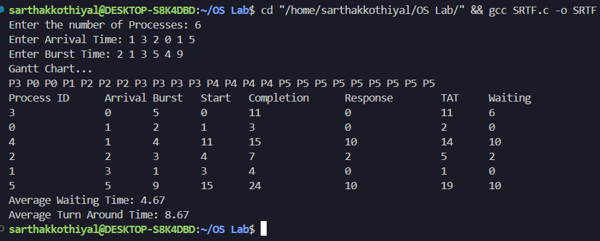

WEEK 4: Ques 1

Given a list of processes, their CPU burst times and arrival times, print the Gantt chart for the following given scheduling policies. Also find averag waiting time and average turnaround time required for complete execution of these processes.
- Priority (non-preemptive) – process which has highest priority will get CPU first.

SOURCE CODE:
#include <stdlib.h>
#include <stdio.h>
#include <unistd.h>
#include <stdbool.h>
#include <limits.h>
struct process{
int id;
int arrival_time;
int burst;
int starting_time;
int completion_time;
int turn_around;
int waiting_time;
int response_time;
int priority;
};
typedef struct process process;
int main(){
int n;
printf("Enter number of Processes: ");
scanf("%d",&n);
bool *iscompleted=(bool*)malloc(n*sizeof(bool));
for(int i=0;i<n;i++)iscompleted[i]=false;
bool is_first_process=true;
process P[n];
printf("Enter Arrival Time: ");
for(int i=0;i<n;i++){
scanf("%d",&P[i].arrival_time);
P[i].id=i;
}
printf("Enter Burst Time: ");
for(int i=0;i<n;i++){
scanf("%d",&P[i].burst);
}
printf("Enter Priority of Processes: ");
for(int i=0;i<n;i++){
scanf("%d",&P[i].priority);
}
int time=0;
int completed=0;
int gantt[n],idx=0;
while(completed!=n){
int min=-1;
int maxpriority=INT_MIN;
for(int i=0;i<n;i++){
if(P[i].arrival_time<=time && !iscompleted[i]){
if(P[i].priority>maxpriority){
maxpriority=P[i].priority;
min=i;
}
else if(P[i].priority==maxpriority){
if(P[i].arrival_time<P[min].arrival_time){
min=i;
}
else if(P[i].arrival_time==P[min].arrival_time){
if(P[i].id<P[min].id){
min=i;
}
}
}
}
}
if(min==-1){
time++;
}
else{
completed++;
iscompleted[min]=true;
P[min].starting_time=time;
P[min].completion_time=P[min].starting_time+P[min].burst;
P[min].turn_around=P[min].completion_time-P[min].arrival_time;
P[min].waiting_time=P[min].turn_around-P[min].burst;
P[min].response_time=P[min].starting_time-P[min].arrival_time;
gantt[idx++]=min;
time+=P[min].burst;
}
}
printf("Gantt Chart...\n");
for(int i=0;i<n;i++){
printf("P%d ", gantt[i]);
}
printf("\n");
printf("Process ID\tArrival\tBurst\tStart\tCompletion\tResponse\tTAT\tWaiting\n");
for(int i=0;i<n;i++){
printf("%d\t\t%d\t%d\t%d\t%d\t\t%d\t\t%d\t%d\n",P[i].id,P[i].arrival_time,P[i].burst,P[i].starting_time,P[i].completion_time,P[i].response_time,P[i].turn_around,P[i].waiting_time);
}
return 0;
}

OUTPUT:

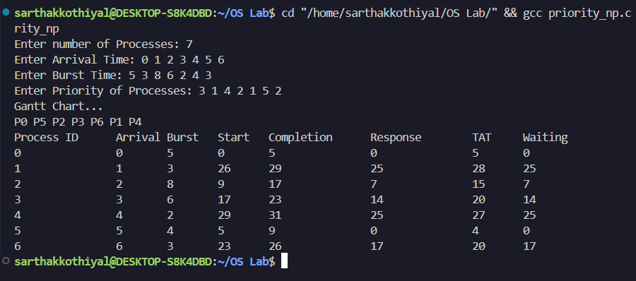

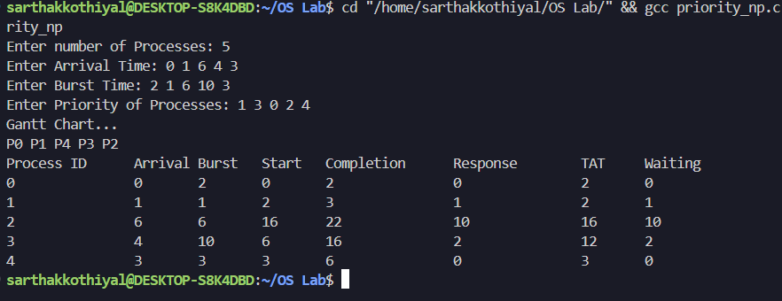

- Priority (Preemptive) – process which has highest priority will get CPU first.

SOURCE CODE:
#include <stdlib.h>
#include <stdio.h>
#include <unistd.h>
#include <stdbool.h>
#include <limits.h>

struct process{
int id;
int arrival_time;
int burst;
int remaining_time;
int starting_time;
int completion_time;
int turn_around;
int waiting_time;
int response_time;
int priority;
bool started;
};
typedef struct process process;
int main(){
int n;
printf("Enter number of Processes: ");
scanf("%d",&n);
process P[n];
printf("Enter Arrival Time: ");
for(int i=0;i<n;i++){
scanf("%d",&P[i].arrival_time);
P[i].id=i;
}
printf("Enter Burst Time: ");
for(int i=0;i<n;i++){
scanf("%d",&P[i].burst);
P[i].remaining_time=P[i].burst;
P[i].started=false;
}
printf("Enter Priority of Processes: ");
for(int i=0;i<n;i++){
scanf("%d",&P[i].priority);
}
int time=0,completed=0;
int gantt[1000],idx=0;
while(completed!=n){
int min=-1,maxpriority=INT_MIN;
for(int i=0;i<n;i++){
if(P[i].arrival_time<=time && P[i].remaining_time>0){
if(P[i].priority>maxpriority){
maxpriority=P[i].priority;
min=i;
}
else if(P[i].priority==maxpriority){
if(P[i].arrival_time<P[min].arrival_time){
min=i;
}
else if(P[i].arrival_time==P[min].arrival_time){
if(P[i].id<P[min].id){
min=i;
}
}
}
}
}
if(min==-1){
time++;
}
else{
if(!P[min].started){
P[min].starting_time=time;
P[min].response_time=P[min].starting_time-P[min].arrival_time;
P[min].started=true;
}
gantt[idx++]=min;
P[min].remaining_time--;
time++;
if(P[min].remaining_time==0){
completed++;
P[min].completion_time=time;
P[min].turn_around=P[min].completion_time-P[min].arrival_time;
P[min].waiting_time=P[min].turn_around-P[min].burst;
}
}
}
printf("\nGantt Chart...\n");
for(int i=0;i<idx;i++){
if(i==0||gantt[i]!=gantt[i-1]) printf("P%d ",gantt[i]);
}
printf("\n");
printf("Process ID\tArrival\tBurst\tStart\tCompletion\tResponse\tTAT\tWaiting\n");
for(int i=0;i<n;i++){
printf("P%d\t\t%d\t%d\t%d\t%d\t\t%d\t\t%d\t%d\n",P[i].id,P[i].arrival_time,P[i].burst,P[i].starting_time,P[i].completion_time,P[i].response_time,P[i].turn_around,P[i].waiting_time);
}
return 0;
}
OUTPUT:

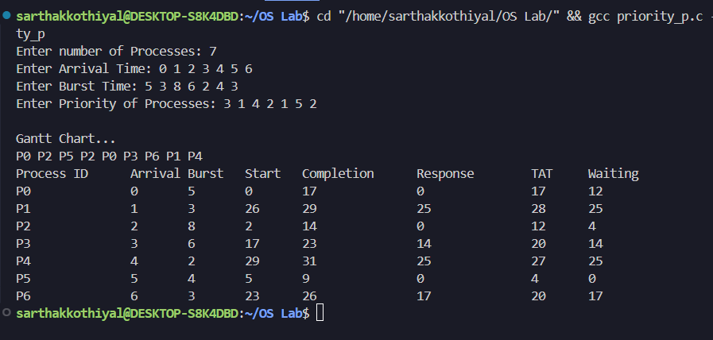

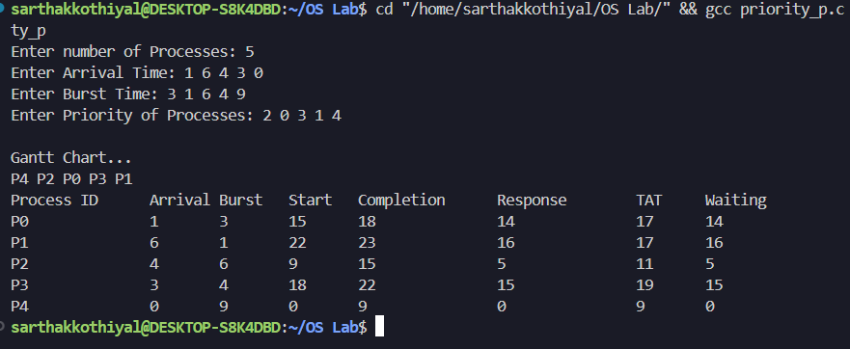

WEEK 4: Ques 2

Round Robin – each process is provided a fix Ame to execute. Once a process is executed for a given Ame period, it is preempted and other process executes for the given Ame period.
Consider Ame quantum = 2 units.

SOURCE CODE:

#include <stdio.h>
#include <stdlib.h>
#include <stdbool.h>
#include <limits.h>

typedef struct process{
int id;
int arrival_time;
int burst;
int starting_time;
int completion_time;
int turn_around;
int waiting_time;
int remaining_time;
int response_time;
bool started;
}process;

int findmax(int a,int b){
return a>b?a:b;
}

int main(){
int n;
printf("Enter number of Processes: ");
scanf("%d",&n);
process P[n];
printf("Enter Arrival Time: ");
for(int i=0;i<n;i++){
scanf("%d",&P[i].arrival_time);
P[i].id=i;
P[i].started=false;
}
printf("Enter Burst Time: ");
for(int i=0;i<n;i++){
scanf("%d",&P[i].burst);
P[i].remaining_time=P[i].burst;
}
int tq;
printf("Enter Time Quantum: ");
scanf("%d",&tq);

int time=0,completed=0;
int queue[10000],front=-1,rear=-1;
bool inqueue[n];
for(int i=0;i<n;i++) inqueue[i]=false;
float sum_tat=0,sum_wt=0,sum_rt=0;
bool first_process=true;
int total_idle=0;

int gantt[10000],idx=0;

queue[++rear]=0;
inqueue[0]=true;

while(completed<n){
int cur=queue[++front];
if(P[cur].remaining_time==P[cur].burst){
P[cur].starting_time=findmax(time,P[cur].arrival_time);
if(first_process) total_idle=0;
else total_idle+=P[cur].starting_time-time;
time=P[cur].starting_time;
P[cur].response_time=P[cur].starting_time-P[cur].arrival_time;
P[cur].started=true;
first_process=false;
}
int run=(P[cur].remaining_time<tq)?P[cur].remaining_time:tq;
for(int k=0;k<run;k++){
gantt[idx++]=cur;
time++;
for(int i=0;i<n;i++){
if(P[i].remaining_time>0 && P[i].arrival_time<=time && !inqueue[i]){
queue[++rear]=i;
inqueue[i]=true;
}
}
}
P[cur].remaining_time-=run;
if(P[cur].remaining_time==0){
completed++;
P[cur].completion_time=time;
P[cur].turn_around=P[cur].completion_time-P[cur].arrival_time;
P[cur].waiting_time=P[cur].turn_around-P[cur].burst;
sum_tat+=P[cur].turn_around;
sum_wt+=P[cur].waiting_time;
sum_rt+=P[cur].response_time;
}
else{
queue[++rear]=cur;
}
if(front>rear){
for(int i=0;i<n;i++){
if(P[i].remaining_time>0){
queue[++rear]=i;
inqueue[i]=true;
break;
}
}
}
}

int max_completion=INT_MIN;
for(int i=0;i<n;i++) if(P[i].completion_time>max_completion) max_completion=P[i].completion_time;
int length_cycle=max_completion-P[0].arrival_time;
float cpu_util=(float)(length_cycle-total_idle)/length_cycle;

printf("\nGantt Chart...\n");
for(int i=0;i<idx;i++){
if(i==0||gantt[i]!=gantt[i-1]){
printf("P%d ",gantt[i]);
}
}
printf("\n");

printf("Process ID\tArrival\tBurst\tStart\tCompletion\tResponse\tTAT\tWaiting\n");
for(int i=0;i<n;i++){
printf("P%d\t\t%d\t%d\t%d\t%d\t\t%d\t\t%d\t%d\n",
P[i].id,P[i].arrival_time,P[i].burst,
P[i].starting_time,P[i].completion_time,
P[i].response_time,P[i].turn_around,P[i].waiting_time);
}
printf("\nAverage Turn Around time= %.2f",(float)sum_tat/n);
printf("\nAverage Waiting Time= %.2f",(float)sum_wt/n);
printf("\nAverage Response Time= %.2f",(float)sum_rt/n);
printf("\nThroughput= %.2f",n/(float)length_cycle);
printf("\nCPU Utilization(Percentage)= %.2f",cpu_util*100);
return 0;
}
OUTPUT:

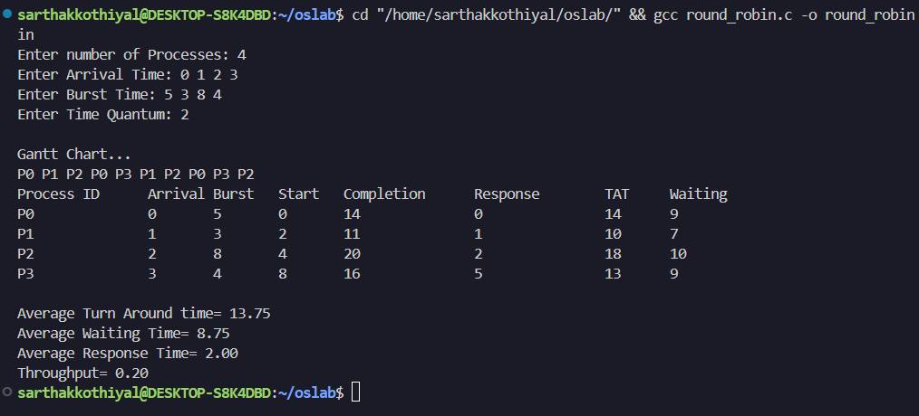

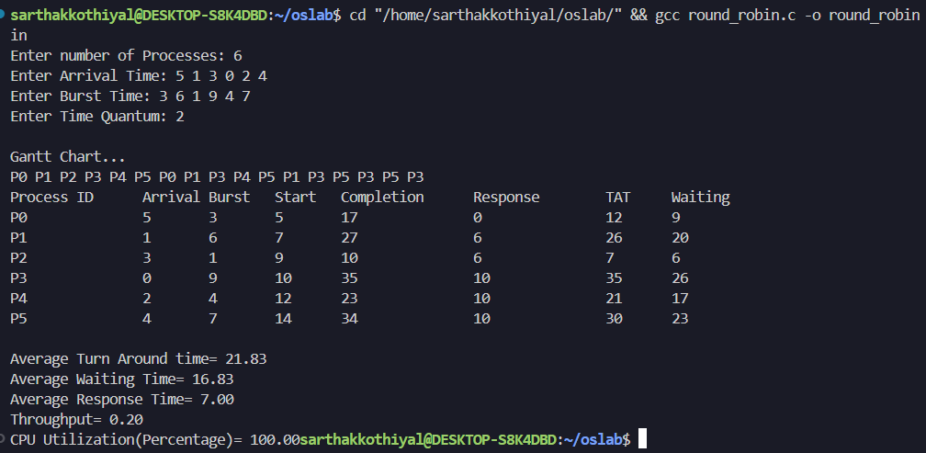

WEEK 5: Ques 1

Write a C program to simulate Bankers algorithm for the purpose of deadlock avoidance.

SOURCE CODE:

#include <stdio.h>
#include <stdlib.h>
#include <stdbool.h>

typedef struct resource{
int A;
int B;
int C;
}resource;

int main(){
int a,b,c;
printf("Enter available resources at CPU (A, B, C): ");
scanf("%d %d %d",&a,&b,&c);
int n;
printf("Enter number of Processes: ");
scanf("%d",&n);
resource allocated[n],max_need[n],remaining[n],available[n];
int avA=0,avB=0,avC=0;
bool *iscompleted=(bool *)malloc(n*sizeof(bool));
printf("Enter Currently Allocated Resources\n");
for(int i=0;i<n;i++){
iscompleted[i]=false;
int a_,b_,c_;
scanf("%d %d %d",&a_,&b_,&c_);
allocated[i].A=a_,allocated[i].B=b_,allocated[i].C=c_;
avA+=a_,avB+=b_,avC+=c_;
}
printf("Enter Max Needed Resources\n");
for(int i=0;i<n;i++){
scanf("%d %d %d",&max_need[i].A,&max_need[i].B,&max_need[i].C);
}
for(int i=0;i<n;i++){
remaining[i].A=max_need[i].A-allocated[i].A;
remaining[i].B=max_need[i].B-allocated[i].B;
remaining[i].C=max_need[i].C-allocated[i].C;
}
avA=a-avA,avB=b-avB,avC=c-avC;
int gantt[n],idx=0;
int completed=0;
for(int j=0;j<n;j++){
for(int i=0;i<n;i++){
if(remaining[i].A<=avA && remaining[i].B<=avB && remaining[i].C<=avC && iscompleted[i]==false){
avA+=allocated[i].A;
avB+=allocated[i].B;
avC+=allocated[i].C;
gantt[idx++]=i;
iscompleted[i]=true;
completed++;
available[i].A=avA;
available[i].B=avB;
available[i].C=avC;
break;
}
}
}
printf("\nGantt Chart...\n");
for(int i=0;i<idx;i++){
printf("P%d ",gantt[i]);
}
printf("\n\nProcess\tAllocated\tMax\t\tNeed\tAvailable After\n");
for(int i=0;i<n;i++){
printf("P%d\t%d %d %d\t\t%d %d %d\t\t%d %d %d\t%d %d %d\n",i,allocated[i].A,allocated[i].B,allocated[i].C,max_need[i].A,max_need[i].B,max_need[i].C,remaining[i].A,remaining[i].B,remaining[i].C,available[i].A,available[i].B,available[i].C);
}
return 0;
}

OUTPUT:

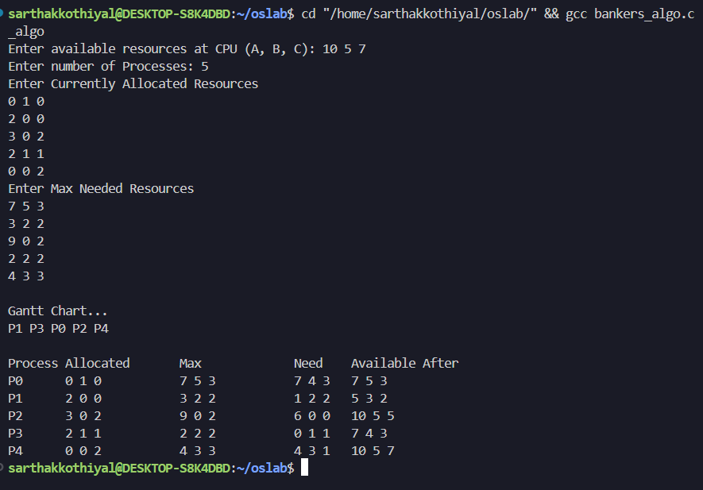

WEEK 5: Ques 2

Write a program to implement deadlock detection algorithm.

SOURCE CODE:

#include <stdio.h>
#include <stdlib.h>
#include <stdbool.h>

typedef struct resource{
int A;
int B;
int C;
}resource;

int main(){
int a,b,c;
printf("Enter available resources at CPU (A, B, C): ");
scanf("%d %d %d",&a,&b,&c);
int n;
printf("Enter number of Processes: ");
scanf("%d",&n);
resource allocated[n],request[n];
bool *finish=(bool *)malloc(n*sizeof(bool));
for(int i=0;i<n;i++) finish[i]=false;

printf("Enter Currently Allocated Resources\n");
for(int i=0;i<n;i++){
scanf("%d %d %d",&allocated[i].A,&allocated[i].B,&allocated[i].C);
}
printf("Enter Max Needed Resources\n");
for(int i=0;i<n;i++){
scanf("%d %d %d",&request[i].A,&request[i].B,&request[i].C);
}

resource work={a,b,c};
int completed=0;
bool progress=true;
while(progress){
progress=false;
for(int i=0;i<n;i++){
if(!finish[i] && request[i].A<=work.A && request[i].B<=work.B && request[i].C<=work.C){
work.A+=allocated[i].A;
work.B+=allocated[i].B;
work.C+=allocated[i].C;
finish[i]=true;
completed++;
progress=true;
}
}
}
if(completed==n){
printf("\nDeadlock NOT detected...\n");
}
else{
printf("\nDeadlock detected!!!\n");
}
return 0;
}

OUTPUT:

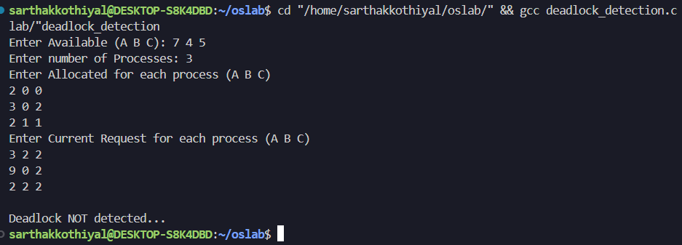

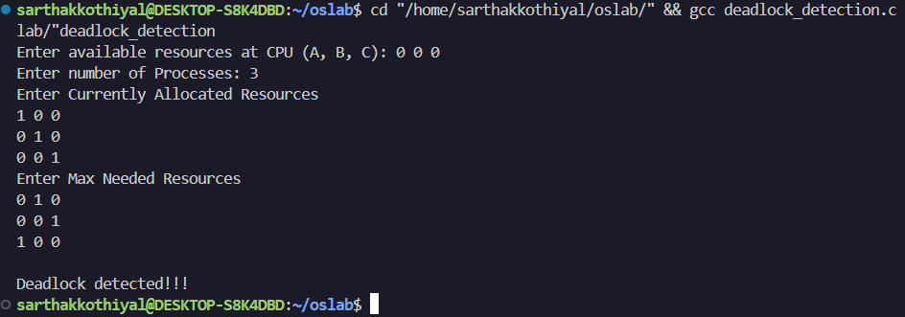

WEEK 6: Ques 1
Write a program to communicate parent and child process with each other in such a way that whenever child writes something, parent process can read it. Consider mode of communication is through

a) pipe
#include <stdio.h>
#include <unistd.h>
int main(){
int p[2];
int returnstatus;
char writing[2][25]={"Hello","World"};
char readmsg[25];
returnstatus=pipe(p);
if(returnstatus==-1){
printf("Pipe Not Created...");
}
printf("\nWriting Status: %s\n",writing[0]);
write(p[1],writing[0],sizeof(writing[0]));
read(p[0],readmsg,sizeof(readmsg));
printf("Reading from pipe-msg1: %s\n",readmsg);
return 0;
}

OUTPUT

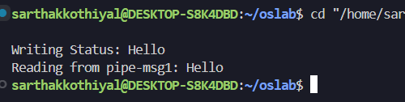

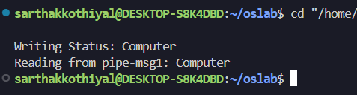

b) message passing
#include <stdio.h>
#include <unistd.h>
#include <sys/types.h>
#include <sys/ipc.h>
#include <sys/msg.h>
#include <string.h>

struct msg_buffer{
long msg_type;
char msg_text[1000];
}message;

int main(){
key_t key;
int msgid;
key=ftok("progfile",65);
msgid=msgget(key,0666 | IPC_CREAT);
message.msg_type=1;
if(fork()==0){
strcpy(message.msg_text,"Message from Child");
msgsnd(msgid,&message,sizeof(message.msg_text),0);
}
else{
msgrcv(msgid,&message,sizeof(message.msg_text),1,0);
printf("Parent read: %s\n",message.msg_text);
msgctl(msgid,IPC_RMID,NULL);
}
return 0;
}

OUTPUT

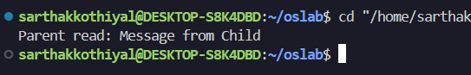
c) shared memory
// Shared Memory Writer
#include <stdio.h>
#include <string.h>
#include <sys/ipc.h>
#include <sys/shm.h>
#include <sys/types.h>

int main() {
key_t key = ftok("shmfile",'A');
int shmid = shmget(key, 1024, 0666 | IPC_CREAT);
char *ptr = (char*) shmat(shmid, NULL, 0);
printf("Input Data : ");
fgets(ptr, 1024, stdin);
shmdt(ptr);
return 0;
}
// Shared Memory Reader
#include <stdio.h>
#include <sys/ipc.h>
#include <sys/shm.h>
#include <sys/types.h>
int main() {
key_t key = ftok("shmfile", 'A');
int shmid = shmget(key, 1024, 0666 | IPC_CREAT);
char *ptr = (char*) shmat(shmid, NULL, 0);
printf("The Data stored : %s", ptr);
shmdt(ptr);
shmctl(shmid, IPC_RMID, NULL);
return 0;
}

OUTPUT:-

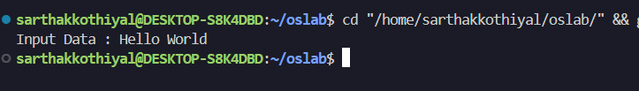

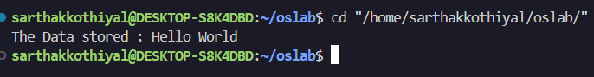

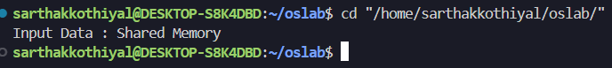

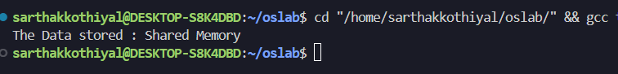

WEEK 6: Ques 2
Write a program to implement the concept of Producer-Consumer problem using semaphores.
SOURCE CODE:
#include <stdio.h>
#include <pthread.h>
#include <semaphore.h>
#include <unistd.h>

#define BUFFER_SIZE 5
int buffer[BUFFER_SIZE];
int in=0,out=0;
sem_t empty;
sem_t full;
sem_t mutex;

void *producer(){
int item;
for(int i=0;i<10;i++){
item=i+1;
sem_wait(&empty);
sem_wait(&mutex);
buffer[in]=item;
printf("Producer produced: %d\n",item);
in=(in+1)%BUFFER_SIZE;
sem_post(&mutex);
sem_post(&full);
sleep(1);
}
return NULL;
}

void *consumer(){
int item;
for(int i=0;i<10;i++){
sem_wait(&full);
sem_wait(&mutex);
item=buffer[out];
printf("Consumer consumed: %d\n",item);
out=(out+1)%BUFFER_SIZE;
sem_post(&mutex);
sem_post(&empty);
sleep(2);
}
return NULL;
}

int main(){
pthread_t prod,cons;
sem_init(&empty,0,BUFFER_SIZE);
sem_init(&full,0,0);
sem_init(&mutex,0,1);
pthread_create(&prod,NULL,producer,NULL);
pthread_create(&cons,NULL,consumer,NULL);
pthread_join(prod,NULL);
pthread_join(cons,NULL);
sem_destroy(&empty);
sem_destroy(&full);
sem_destroy(&mutex);
return 0;
}

OUTPUT:-

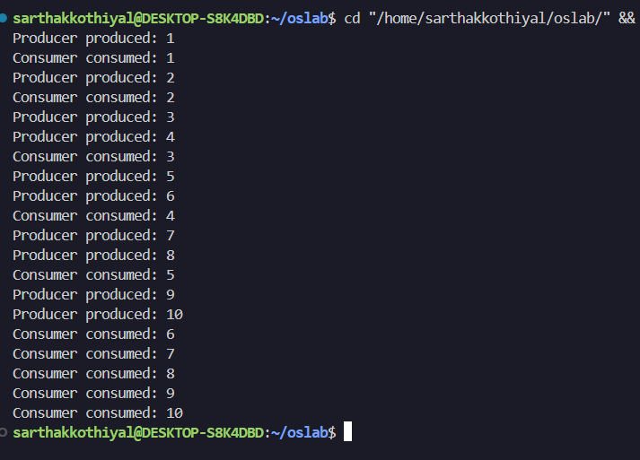

WEEK 6: Ques 3
Write a program to implement the concept of Dining-Philosopher problem
SOURCE CODE
#include <stdio.h>
#include <pthread.h>
#include <semaphore.h>
#include <unistd.h>

#define N 3

sem_t chopstick[N];

void *philosopher(void *num){
int id=*(int*)num;
while(1){
printf("Philosopher %d is THINKING\n",id);
sleep(3);
int left=id;
int right=(id+1)%N;
if(sem_trywait(&chopstick[left])==0){
if(sem_trywait(&chopstick[right])==0){
printf("Philosopher %d is EATING\n",id);
sleep(2);
sem_post(&chopstick[right]);
sem_post(&chopstick[left]);
printf("Philosopher %d finished EATING\n", id);
}
else{
sem_post(&chopstick[left]);
}
}
usleep(100);
}
}

int main(){
pthread_t tid[N];
int ids[N];
for(int i=0;i<N;i++){
sem_init(&chopstick[i],0,1);
}
for(int i=0;i<N;i++){
ids[i]=i;
pthread_create(&tid[i],NULL,philosopher,&ids[i]);
}
for(int i=0;i<N;i++){
pthread_join(tid[i], NULL);
}
return 0;
}

OUTPUT:-
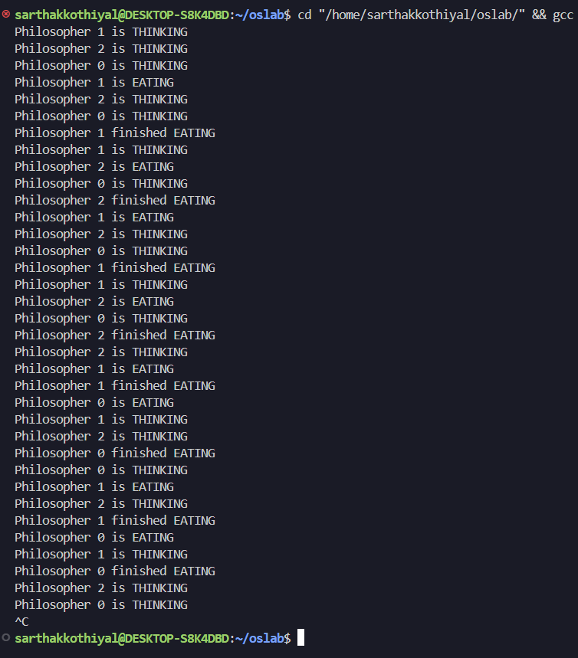

WEEK 7: Ques 1

FIFO – First In First Out : page which came first (i.e. oldest page) need to be moved out.

SOURCE CODE
#include <stdio.h>
#include <stdlib.h>
#include <stdbool.h>

int main(){
int s;
printf("Enter size of input string: ");
scanf("%d",&s);
int *nums=(int*)malloc(s*sizeof(int));
printf("Enter input string...\n");
for(int i=0;i<s;i++){
scanf("%d",&nums[i]);
}
int n;
printf("Enter size of page array: ");
scanf("%d",&n);
int *page=(int*)malloc(n*sizeof(int));
for(int i=0;i<n;i++){
page[i]=-1;
}
int idx=0;
double hit=0.00,miss=0.00;
for(int i=0;i<s;i++){
int p=nums[i];
bool found=false;
for(int j=0;j<n;j++){
if(page[j]==p){
found=true;hit++;
break;
}
}
if(!found){
miss++;
page[idx++]=p;
idx=idx%n;
}
printf("Current Page container...\n");
for(int k=0;k<n;k++){
if(page[k]==-1){printf(" - ");}
else{printf("[%d]",page[k]);}
}
printf("\n");
}
double attempts=hit+miss;
double hit_ratio=hit/attempts;
double miss_ratio=miss/attempts;
printf("Total Attempts: %.0f\n",attempts);
printf("Hit Ratio: %.2f, (Total Hits: %.0f)\n",hit_ratio,hit);
printf("Miss Ratio: %.2f, (Total Misses: %.0f)",miss_ratio,miss);
return 0;
}

OUTPUT

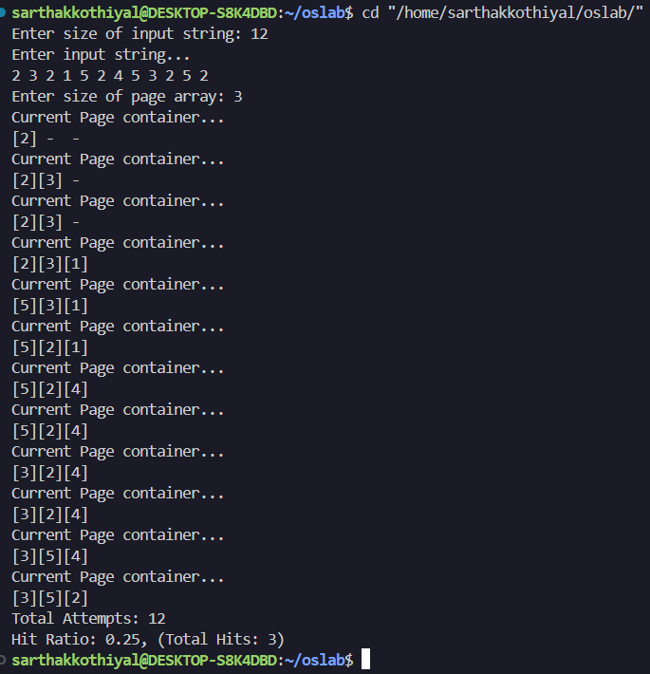

WEEK 7: Ques 2

LRU – Least Recently Used: page which is has not been used for longest Ame need to be moved out.

SOURCE CODE
#include <stdio.h>
#include <stdlib.h>
#include <stdbool.h>
int main(){
int s;
printf("Enter size of input string: ");
scanf("%d",&s);
int *nums=(int*)malloc(s*sizeof(int));
printf("Enter input string...\n");
for(int i=0;i<s;i++){
scanf("%d",&nums[i]);
}
int n;
printf("Enter size of page array: ");
scanf("%d",&n);
int *page=(int*)malloc(n*sizeof(int));
for(int i=0;i<n;i++){page[i]=-1;}
int *index=(int*)malloc(n*sizeof(int));
for(int i=0;i<n;i++){index[i]=-1;}
double hit=0.00,fault=0.00;
for(int i=0;i<s;i++){
int p=nums[i];
bool found=false;
for(int j=0;j<n;j++){
if(page[j]==p){
index[j]=i;
hit++;found=true;
break;
}
}
if(!found){
int minindex=0;int minelement=index[0];
for(int j=0;j<n;j++){
if(index[j]<minelement){
minindex=j;minelement=index[j];
}
}
page[minindex]=p;
index[minindex]=i;
fault++;
}
printf("Current Page container...\n");
for(int k=0;k<n;k++){
if(page[k]==-1){printf(" - ");}
else{printf("[%d]",page[k]);}
}
printf("\n");
}
double attempts=hit+fault;
double hit_ratio=hit/attempts;
double fault_ratio=fault/attempts;
printf("Total Attempts: %.0f\n",attempts);
printf("Hit Ratio: %.2f, (Total Hits: %.0f)\n",hit_ratio,hit);
printf("Fault Ratio: %.2f, (Total Fault Pages: %.0f)",fault_ratio,fault);
return 0;
}

OUTPUT
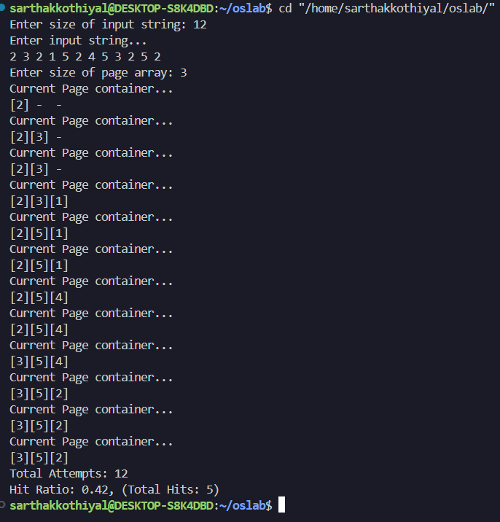

WEEK 8: Ques 1
Best Fit – block which is closes to the size of request is allocated i.e. the smallest hole that is big enough to allocate to the requesAng program.
SOURCE CODE
#include <stdio.h>
#include <stdlib.h>
#include <stdbool.h>

int main(){
int n;
printf("Enter number of free blocks: ");
scanf("%d",&n);
int *ram=(int *)malloc(n*sizeof(int));
printf("Enter RAM blocks...\n");
for(int i=0;i<n;i++){
scanf("%d",&ram[i]);
}
int p;
printf("Enter number of Processes: ");
scanf("%d",&p);
int *process=(int *)malloc(p*sizeof(int));
printf("Enter processes...\n");
for(int i=0;i<p;i++){
scanf("%d",&process[i]);
}
int *result=(int *)malloc(n*sizeof(int));
int *filled=(int *)calloc(n,sizeof(int));
for(int i=0;i<n;i++){result[i]=-1;}
for(int i=0;i<p;i++){
int pro=process[i];
int minwaste=1e9;int minidx=-1;
for(int j=0;j<n;j++){
if(ram[j]>=pro && !filled[j]){
if(ram[j]-pro<minwaste){
minidx=j;
minwaste=ram[j]-pro;
}
}
}
if(minidx!=-1){
result[minidx]=pro;
filled[minidx]=1;
}
}
for(int i=0;i<n;i++){
if(result[i]==-1){
printf("RAM block %d is free...\n",i);
}
else{
printf("Process: %d allocated to RAM block(size: %d): %d\n",result[i],ram[i],i);
}
}
return 0;
}

OUTPUT

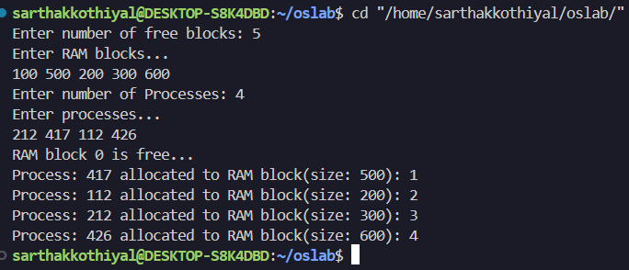

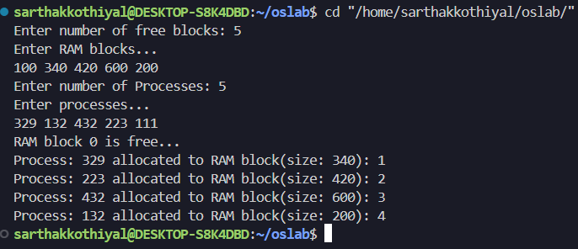

WEEK 8: Ques 2

First Fit – start searching the list from beginning, take the first block whose size is greater than or equal to the requesAng program size and allocate it to program.

SOURCE CODE
#include <stdio.h>
#include <stdlib.h>
#include <stdbool.h>

int main(){
int n;
printf("Enter number of free blocks: ");
scanf("%d",&n);
int *ram=(int *)malloc(n*sizeof(int));
printf("Enter RAM blocks...\n");
for(int i=0;i<n;i++){
scanf("%d",&ram[i]);
}
int p;
printf("Enter number of Processes: ");
scanf("%d",&p);
int *process=(int *)malloc(p*sizeof(int));
printf("Enter processes...\n");
for(int i=0;i<p;i++){
scanf("%d",&process[i]);
}
int *result=(int *)malloc(n*sizeof(int));
int *filled=(int *)calloc(n,sizeof(int));
for(int i=0;i<n;i++){result[i]=-1;}
for(int i=0;i<p;i++){
int pro=process[i];
for(int j=0;j<n;j++){
if(ram[j]>=pro && !filled[j]){
result[j]=pro;filled[j]=1;break;
}
}
}
for(int i=0;i<n;i++){
if(result[i]==-1){
printf("RAM block %d is free...\n",i);
}
else{
printf("Process: %d allocated to RAM block(size: %d): %d\n",result[i],ram[i],i);
}
}
return 0;
}

OUTPUT

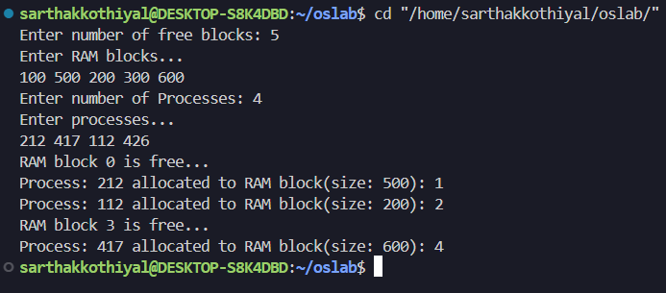

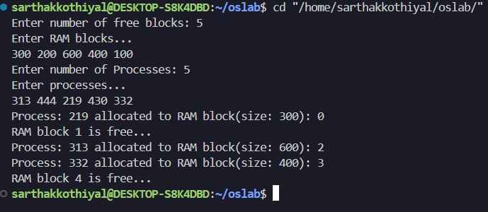

WEEK 8: Ques 3
Worst Fit – block which is largest among all is allocated for the program
SOURCE CODE

#include <stdio.h>
#include <stdlib.h>
#include <stdbool.h>

int main(){
int n;
printf("Enter number of free blocks: ");
scanf("%d",&n);
int *ram=(int *)malloc(n*sizeof(int));
printf("Enter RAM blocks...\n");
for(int i=0;i<n;i++){
scanf("%d",&ram[i]);
}
int p;
printf("Enter number of Processes: ");
scanf("%d",&p);
int *process=(int *)malloc(p*sizeof(int));
printf("Enter processes...\n");
for(int i=0;i<p;i++){
scanf("%d",&process[i]);
}
int *result=(int *)malloc(n*sizeof(int));
int *filled=(int *)calloc(n,sizeof(int));
for(int i=0;i<n;i++){result[i]=-1;}
for(int i=0;i<p;i++){
int pro=process[i];
int maxwaste=-1e9;int maxidx=-1;
for(int j=0;j<n;j++){
if(ram[j]>=pro && !filled[j]){
if(ram[j]-pro>maxwaste){
maxidx=j;
maxwaste=ram[j]-pro;
}
}
}
if(maxidx!=-1){
result[maxidx]=pro;
filled[maxidx]=1;
}
}
for(int i=0;i<n;i++){
if(result[i]==-1){
printf("RAM block %d is free...\n",i);
}
else{
printf("Process: %d allocated to RAM block(size: %d): %d\n",result[i],ram[i],i);
}
}
return 0;
}

OUTPUT

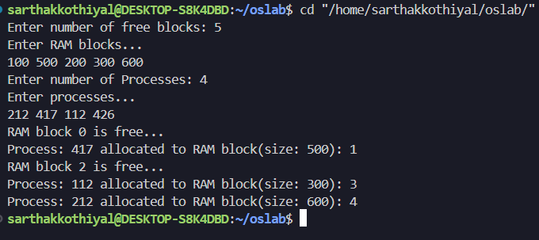

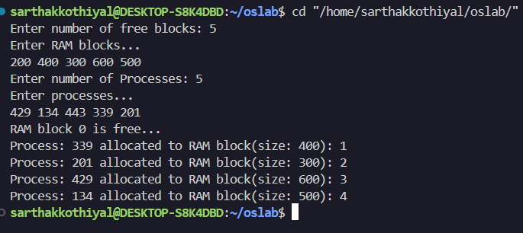

WEEK 9-10: Ques 1
Sequential/Contiguous – each file occupied contiguous blocks on the disk. A record of a
sequential file can only be accessed by reading all the previous records
SOURCE CODE

#include <stdio.h>
#include <string.h>

struct file{
char name[10];
int start,len,blocks[50];
};

int main(){
int n,i,j;
struct file f[10];
char search[10];
printf("Enter number of files: ");
scanf("%d",&n);
for(i=0;i<n;i++){
printf("Enter file %d name: ",i+1);
scanf("%s",f[i].name);
printf("Enter starting block of file %d: ",i+1);
scanf("%d",&f[i].start);
printf("Enter no of blocks in file %d: ",i+1);
scanf("%d",&f[i].len);
for(j=0;j<f[i].len;j++){
f[i].blocks[j]=f[i].start+j;
}
}
printf("Enter file name to be searched: ");
scanf("%s",search);
for(i=0;i<n;i++){
if(strcmp(f[i].name,search)==0){
printf("File Name\tStart block\tNo. of blocks\tBlocks occupied\n");
printf("%s\t\t%d\t\t%d\t\t",f[i].name,f[i].start,f[i].len);
for(j=0;j<f[i].len;j++){
printf("%d ",f[i].blocks[j]);
}
printf("\n");
return 0;
}
}
printf("File not found\n");
return 0;
}

OUTPUT

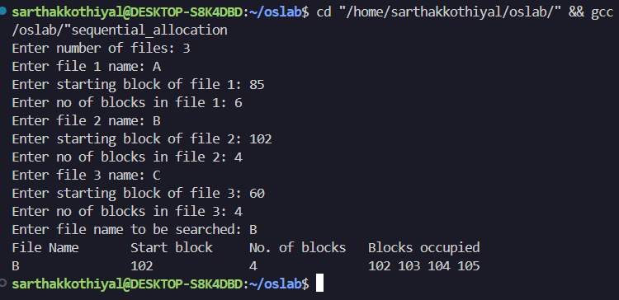

WEEK 9-10: Ques 2
Linked – each file is linked list of disk blocks. the disk blocks may be scaOered anywhere on the disk. The directory contains a pointer to the first and last blocks of the file. Each block contains a pointer to the next block.
SOURCE CODE
#include <stdio.h>
#include <string.h>
struct file{
char name[10];
int start,len,blocks[50],link[50];
};
int main(){
int n,i,j;
struct file f[10];
char search[10];
printf("Enter number of files: ");
scanf("%d",&n);
for(i=0;i<n;i++){
printf("Enter file %d name: ",i+1);
scanf("%s",f[i].name);
printf("Enter starting block of file %d: ",i+1);
scanf("%d",&f[i].start);
printf("Enter no of blocks in file %d: ",i+1);
scanf("%d",&f[i].len);
printf("Enter block numbers of file %d: ",i+1);
for(j=0;j<f[i].len;j++){
scanf("%d",&f[i].blocks[j]);
if(j>0) f[i].link[j-1]=f[i].blocks[j];
}
f[i].link[f[i].len-1]=-1;
}
printf("Enter file name to be searched: ");
scanf("%s",search);
for(i=0;i<n;i++){
if(strcmp(f[i].name,search)==0){
printf("File Name\tStart block\tNo. of blocks\tBlocks occupied (linked)\n");
printf("%s\t\t%d\t\t%d\t\t",f[i].name,f[i].start,f[i].len);
for(j=0;j<f[i].len;j++){printf("%d->",f[i].blocks[j]);}
printf("NULL\n");
return 0;
}
}
printf("File not found\n");
return 0;
}

OUTPUT:
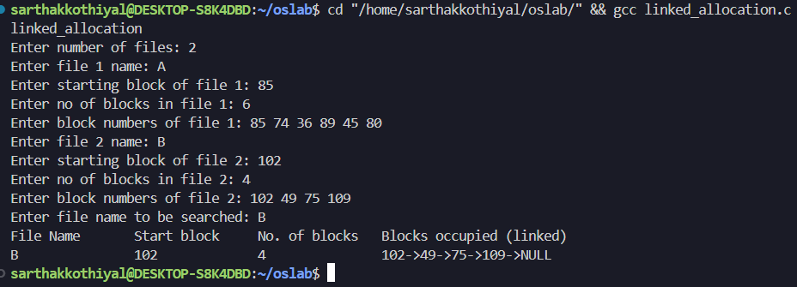

WEEK 9-10: Ques 3
Indexed – index is maintained for the list of all blocks used by the file. Each file has its own index block which is an array of disk-block addresses. The ith entry in the index block points to the ith block of the file. The directory contains the address of the index block.
SOURCE CODE
#include <stdio.h>
#include <string.h>

struct file{
char name[10];
int index,len,blocks[50];
};

int main(){
int n,i,j;
struct file f[10];
char search[10];
printf("Enter number of files: ");
scanf("%d",&n);
for(i=0;i<n;i++){
printf("Enter file %d name: ",i+1);
scanf("%s",f[i].name);
printf("Enter index block of file %d: ",i+1);
scanf("%d",&f[i].index);
printf("Enter no of blocks in file %d: ",i+1);
scanf("%d",&f[i].len);
printf("Enter block numbers of file %d: ",i+1);
for(j=0;j<f[i].len;j++){
scanf("%d",&f[i].blocks[j]);
}
}
printf("Enter file name to be searched: ");
scanf("%s",search);
for(i=0;i<n;i++){
if(strcmp(f[i].name,search)==0){
printf("File Name\tIndex block\tNo. of blocks\tBlocks occupied\n");
printf("%s\t\t%d\t\t%d\t\t",f[i].name,f[i].index,f[i].len);
for(j=0;j<f[i].len;j++){
printf("%d ",f[i].blocks[j]);
}
printf("\n");
return 0;
}
}
printf("File not found\n");
return 0;
}

OUTPUT

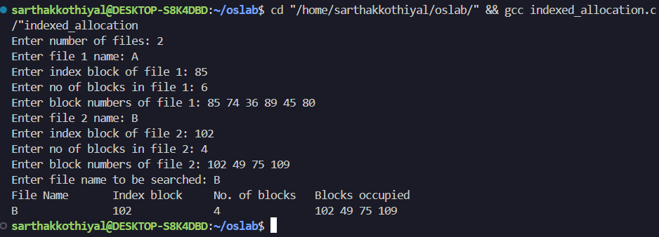

WEEK 11-12: Ques 1
FCFS – First come First Served (Disk Scheduling algorithm)
SOURCE CODE
#include <stdio.h>
#include <stdlib.h>

int main(){
int n;
printf("Enter number of inputs: ");
scanf("%d",&n);
int *nums=(int *)malloc(n*sizeof(int));
for(int i=0;i<n;i++){
scanf("%d",&nums[i]);
}
int disk,head;
printf("Enter Head position: ");
scanf("%d",&head);
printf("Enter size of Disk: ");
scanf("%d",&disk);
int result=0;
printf("\nSeek Sequence:\n");
for(int i=0;i<n;i++){
printf("%d-> ",nums[i]);
result+=abs(head-nums[i]);
head=nums[i];
}
printf("\nSeek Count=%d\n",result);
return 0;
}

OUTPUT:-

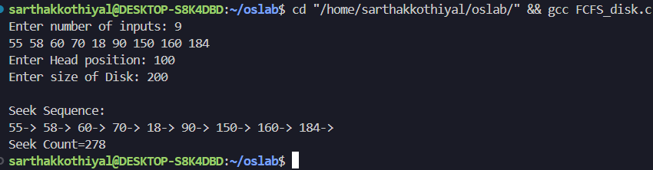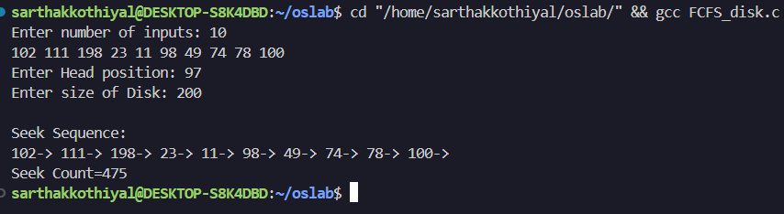

WEEK 11-12: Ques 2
SCAN – The disk arm starts at one end, and moves towards the other end, servicing requests as it reaches each cylinder, until it gets to the other end of the disk. At the other end, the direction of head movement is reversed, and servicing continues. The head continuously scans back and forth across the disk.
SOURCE CODE
#include <stdio.h>
#include <stdlib.h>

int cmp(const void *a, const void *b) {
return (*(int *)a - *(int *)b);
}
int main(){
int n,disk,head;
printf("Enter number of requests: ");
scanf("%d",&n);
int *req=(int *)malloc((n+2)*sizeof(int));
printf("Enter requests: ");
for(int i=0;i<n;i++){
scanf("%d", &req[i]);
}
printf("Enter disk size: ");
scanf("%d", &disk);
printf("Enter head position: ");
scanf("%d", &head);
int dir=(req[0]<head)?1:0; // 1 = left, 0 = right
req[n]=0;
req[n+1]=disk-1;
n+=2;
qsort(req, n, sizeof(int), cmp);
int pos=0;
while(pos<n && req[pos]<head){
pos++;
}
int seek=0,cur=head;
printf("\nSeek Sequence:\n");
if(dir==0){
for(int i=pos;i<n;i++){
printf("%d-> ",req[i]);
seek+=abs(cur-req[i]);
cur=req[i];
}
for(int i=pos-1;i>=0;i--){
printf("%d-> ",req[i]);
seek+=abs(cur-req[i]);
cur=req[i];
}
}
else{
for(int i=pos-1;i>=0;i--){
printf("%d-> ",req[i]);
seek+=abs(cur-req[i]);
cur=req[i];
}
for(int i=pos;i<n;i++){
printf("%d-> ",req[i]);
seek+=abs(cur-req[i]);
cur=req[i];
}
}
printf("\nTotal Seek Count=%d\n", seek);
return 0;
};
OUTPUT: -

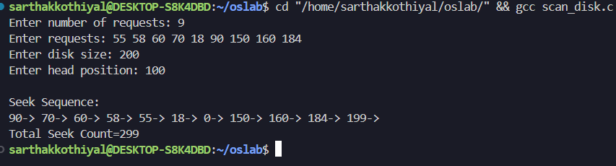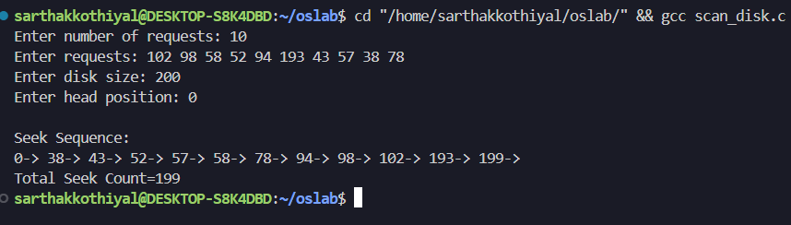

WEEK 11-12: Ques 3
C-SCAN – It moves the head from one end of the disk to the other, servicing requests along the way. When the head reaches the other end, it immediately returns to the beginning of the disk without servicing any requests on the return trip. Once it is returned, it starts moving to other end, servicing requests along the way. It means C-SCAN service requests only in one direction.
SOURCE CODE
#include <stdio.h>
#include <stdlib.h>
int cmp(const void *a,const void *b){
return (*(int*)a-*(int*)b);
}
int main(){
int n;
printf("Enter number of inputs: ");
scanf("%d",&n);
int *nums=(int*)malloc((n+2)*sizeof(int));
for(int i=0;i<n;i++){
scanf("%d",&nums[i]);
}
int disk,head;
printf("Enter size of Disk: ");
scanf("%d",&disk);
printf("Enter Head position: ");
scanf("%d",&head);
int dir=(nums[0]<head)?1:0; //1=left 0=right
nums[n]=0;
nums[n+1]=disk-1;
n+=2;
qsort(nums,n,sizeof(int),cmp);
int pos=0;
while(pos<n && nums[pos]<head) pos++;
int result=0,cur=head;
printf("\nSeek Sequence:\n");
if(dir==0){
for(int i=pos;i<n;i++){
printf("%d-> ",nums[i]);
result+=abs(cur-nums[i]);
cur=nums[i];
}
result+=abs(disk-1-0);
cur=0;
for(int i=0;i<pos;i++){
printf("%d-> ",nums[i]);
result+=abs(cur-nums[i]);
cur=nums[i];
}
}else{
for(int i=pos-1;i>=0;i--){
printf("%d-> ",nums[i]);
result+=abs(cur-nums[i]);
cur=nums[i];
}
result+=abs(cur-0)+abs(disk-1-0);
cur=disk-1;
for(int i=n-2;i>=pos;i--){
printf("%d-> ",nums[i]);
result+=abs(cur-nums[i]);
cur=nums[i];
}
}
printf("\nSeek Count=%d\n",result);
free(nums);
return 0;}
OUTPUT: -

